 | 3580768 CANADA INC, DBA: DST TRANSPORT
 | Driver Name |  |  | Phone#
 | Address: |  |  | Cellular#
 | City |  |  | Postal Code
 | Driver’s Qualification File Checklist
 | Application for Employment |  |  |  |  |  | Completed
 | Employment History and reference check |  |  |  |  |  | Completed
 | Certification of Violations/Annual Review |  |  |  |  |  | Completed
 | Driver's Data Sheet (On-Duty Hours) |  |  |  |  |  | Completed
 | Certificate of Compliance |  |  |  |  |  | Completed
 | Trailer Handling Memo |  |  |  |  |  | Completed
 | Logbook Memo |  |  |  |  |  | Completed
 | Trainings, Policies and Procedures (including Schedule 1) |  |  |  |  |  | Completed
 | Independent Contractors Agreement and WSIB letter of Independence from Owner Operators |  |  |  |  |  | Obtained
 | Photocopy of Current Driver's CVOR and Abstract |  |  |  |  |  | Obtained
 | Dangerous Goods Training |  |  |  |  |  | Obtained
 | Photocopy of Current Driver's License, Second Photo ID |  |  |  |  |  | Completed
 | Road Test Evaluation along with the logbook |  |  |  |  |  | Completed
 | Articles of Incorporation |  |  |  |  |  | Completed
Driver Signature: ____________________________ |  |  |  |  |  |  | Date:
File Approved by: 1) __________________________ |  |  |  |  |  |  | Date:
2) __________________________ |  |  |  |  |  |  | Date:
APPLICATION FOR EMPLOYMENT

COMPANY 3580768 CANADA INC. DBA: DST TRANSPORT

ADDRESS 6505 VIPOND DR, MISSISSAUGA, ON, L5T 1J9
(STREET) CITY, PROVINCE, POSTAL CODE

NAME ____________________________________________________________________________________
(FIRST) (MIDDLE) (Maiden Name, if any) (LAST)

ADDRESS __________________________________________________________________________
(STREET) (CITY) (PROVINCE, POSTAL CODE)

HOW LONG?

DATE OF BIRTH ________________ SOCIAL SECURITY NO. _______________________

HIRE DATE ______________ TELEPHONE NUMBER ______________________________

E-MAIL ADDRESS _______________________________

PREVIOUS THREE YEARS RESIDENCY

__________________________________________________________________________________ # YEARS
(STREET) (CITY) (PROVINCE, POSTAL CODE)

__________________________________________________________________________________ # YEARS
(STREET) (CITY) (PROVINCE, POSTAL CODE)

__________________________________________________________________________________ # YEARS
(STREET) (CITY) (PROVINCE, POSTAL CODE)

(ATTACH SHEET IF MORE SPACE IS NEEDED)
LICENSE INFORMATION
Section 383.21 FMCSR states “No person who operates a commercial motor vehicle shall at any time have more than one driver’s license”. I certify that I do not have more than one motor vehicle license, the information for which is listed below.
STATE | LICENSE NO. | TYPE | EXPIRATION DATE

DRIVING EXPERIENCE
CLASS OF EQUIPMENT | TYPE OF EQUIPMENT  (VAN, TANK, FLAT, ETC.) | DATES  FROM TO | APPROX. NO. OF  MILES (TOTAL)
STRAIGHT TRUCK

TRACTOR AND SEMI-TRAILER

TRACTOR - TWO TRAILERS

ACCIDENT RECORD FOR PAST 3 YEARS OR MORE (ATTACH SHEET IF MORE SPACE IS NEEDED)
DATES | NATURE OF ACCIDENT  (HEAD-ON, REAR-END, UPSET, ETC.) | NUMBER  FATALITIES | NUMBER  INJURIES | CHEMICAL  SPILLS
 |  |  |  | YES NO
 |  |  |  | YES NO
 |  |  |  | YES NO

TRAFFIC CONVICTIONS AND FORFEITURES FOR THE PAST 3 YEARS (OTHER THAN PARKING VIOLATIONS)
DATE CONVICTED  (month/year) | VIOLATION | STATE OF VIOLATION LOCATION | PENALTY  (forfeited bond, collateral and/or points)

(ATTACH SHEET IF MORE SPACE IS NEEDED)

A. Have you ever been denied a license, permit or privilege to operate a motor vehicle? YES _____ NO _____
If yes, explain ______________________________________________________________________________________

B. Has any license, permit or privilege ever been suspended or revoked? YES _____ NO _____
If yes, explain ______________________________________________________________________________________

EMPLOYMENT HISTORY

Applicants that desire to drive in intrastate/interstate commerce must provide the following information on all employers during the previous three years. You must give the same information for all employers you have driven a commercial motor vehicle for the seven years prior to the initial three years (total of ten years’ employment record).

EMPLOYER 1 |  | DATE  {MONTH / YEAR}
NAME: |  | FROM: TO:
ADDRESS: |  | POSITION HELD
CITY: |  | SALARY WAGE
CONTACT PERSON PHONE #: |  | REASONS FOPR LEAVING
EMPLOYER 2 |  | DATE  {MONTH / YEAR}
NAME: |  | FROM: TO:
ADDRESS: |  | POSITION HELD
CITY: |  | SALARY WAGE
CONTACT PERSON PHONE #: |  | REASONS FOPR LEAVING
EMPLOYER 3 |  | DATE  {MONTH / YEAR}
NAME: |  | FROM: TO:
ADDRESS: |  | POSITION HELD
CITY: |  | SALARY WAGE
CONTACT PERSON PHONE #: |  | REASONS FOPR LEAVING
EMPLOYER 4 |  | DATE  {MONTH / YEAR}
NAME: |  | FROM: TO:
ADDRESS: |  | POSITION HELD
CITY: |  | SALARY WAGE
CONTACT PERSON PHONE #: |  | REASONS FOPR LEAVING

EMPLOYER 5 | DATE  {MONTH / YEAR}
NAME: | FROM: TO:
ADDRESS: | POSITION HELD
CITY: | SALARY WAGE
CONTACT PERSON PHONE #: | REASONS FOPR LEAVING

SAFETY PERFORMANCE HISTORY RECORDS REQUEST

PART 1: | TO BE COMPLETED BY PROSPECTIVE EMPLOYEE
I, (Print Name) ______________________________________Social Security Number: _________________
Date of Birth: _______________Previous Employer: _____________________________________________ Email: _____________________Address___________________________ ____
Street City, State, Postal Code
Fax No.: _________________ Telephone: __________________
To: Prospective Employer: 3580768 CANADA INC, DBA: DST TRANSPORT
Attention: ____SAFETY_____________________________ Telephone: 905-670-6613
Address: 6505 VIPOND DR, MISSISSAUGA, ON, L5T 1J9
Street City, State, Postal Code
In compliance with §40.25(g) and 391.23(h), release of this information must be made in a written form that ensures
Confidentiality, such as fax, email, or letter.
Prospective employer’s fax number: ___________________________________
Prospective employer’s email address: _________________________________
_____________________________ __________________________
Applicant’s Signature Date

PART 2: | TO BE COMPLETED BY PREVIOUS EMPLOYER
ACCIDENT HISTORY

The applicant named above was employed by us. Yes No
Employed as _______________________ from (m/y) ______________________ to (m/y) _________________
1. Did he/she drive motor vehicle for you? Yes No If yes, what type? Straight Truck /Tractor-Semitrailer/
Bus/ Cargo Tank Doubles/Triples Other (Specify) ________________________________________________
2. Reason for leaving your employ: Discharged Resignation Lay Off Military Duty
If there is no safety performance history to report, check here , sign below and return.

ACCIDENTS: Complete the following for any accidents included on your accident register (§390.15(b)) that involved the applicant in the 3 years prior to the application date shown above, or check here if there is no accident register data for this driver.
Date Location # Injuries # Fatalities Hazmat Spill
1. _______________ ___________________ __________________ __________________ _______________
2. _______________ ___________________ __________________ __________________ _______________
3. _______________ ___________________ __________________ __________________ _______________
Please provide information concerning any other accidents involving the applicant that were reported to government
agencies or insurers or retained under internal company policies: _________________________________________
____________________________________________________ _____________________________________
Signature: ____________________________________________________
Title: ______________________________ Date: ____________________

PART 3a: | TO BE COMPLETED BY PROSPECTIVE EMPLOYER
This form was (check one) Faxed to previous employer Mailed Emailed Other ______________
By: ______________________________________________ Date: ______________________

PART 3b: | TO BE COMPLETED BY PROSPECTIVE EMPLOYER
Complete below when information is obtained.
Information received from: ____________________________: Recorded by: __________________________ Method: Fax Mail Email Telephone Other ___________ Date: _______________
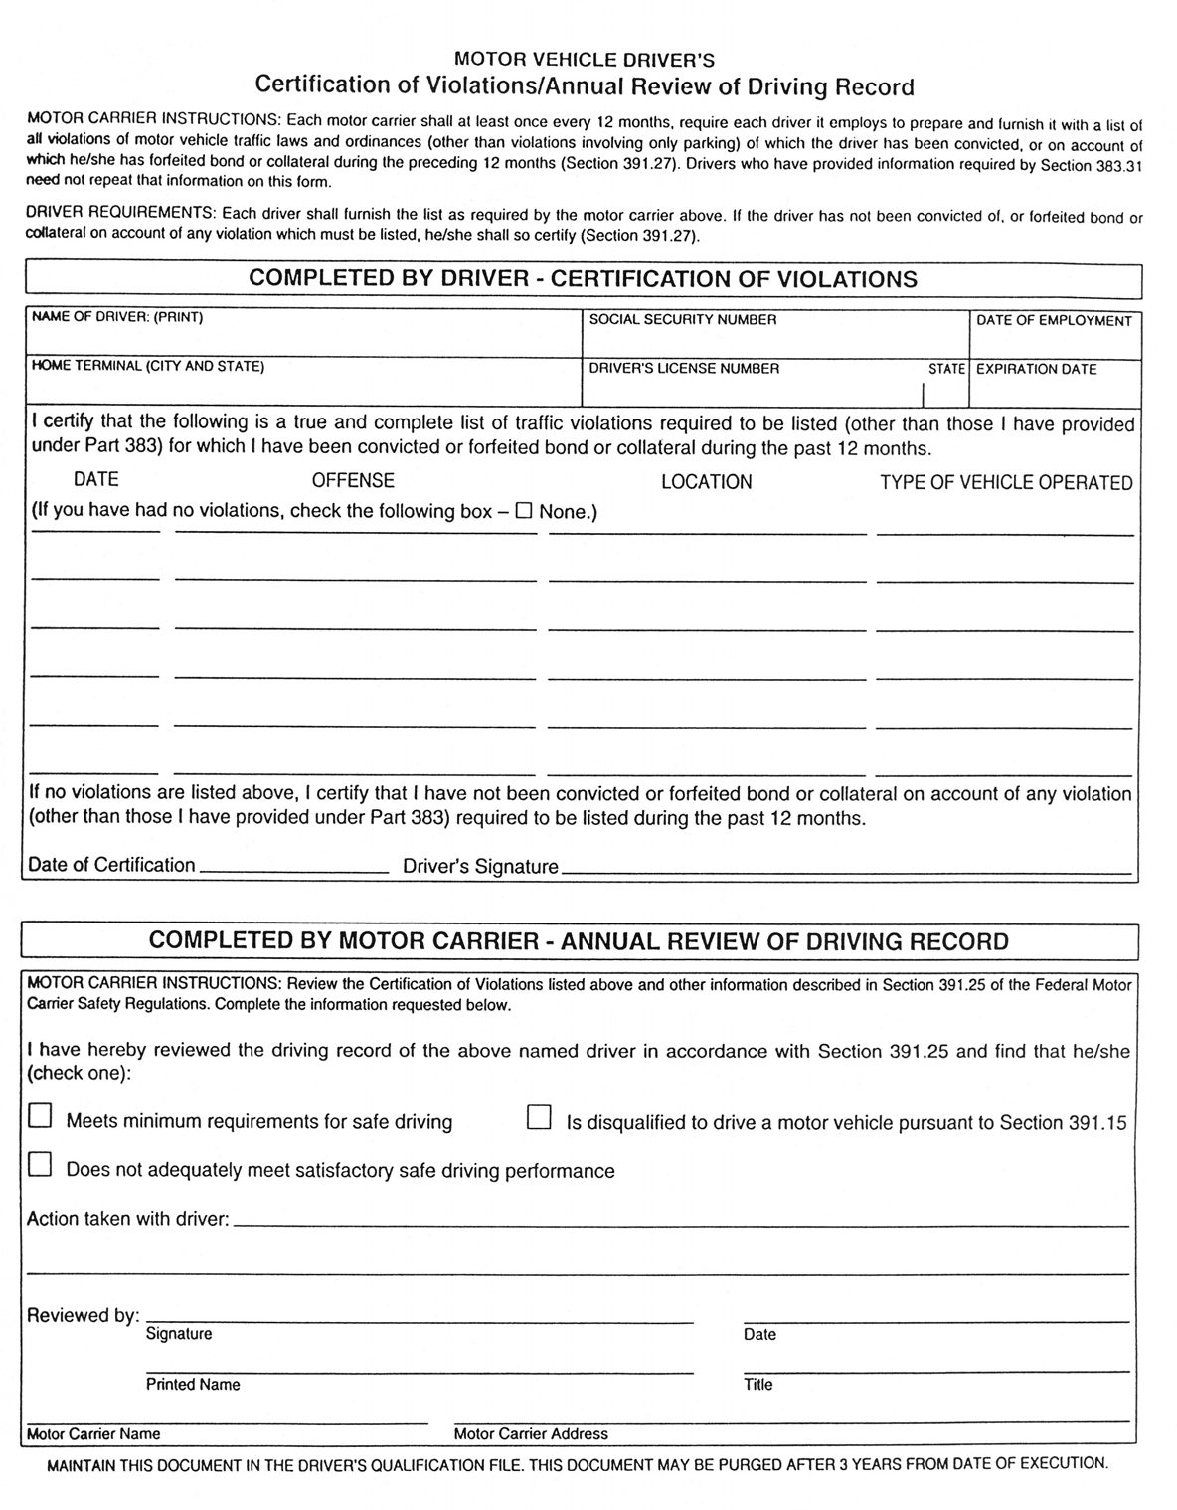
DRIVER DATA SHEET

Name (Print)

Drivers License Number

Class of License: Issuing State/Province:

Instruction: At the time of initial recruitment as a driver, the regulation of the Department of Transportation, Rule 395.8(r), require you to furnish a statement of the amount of time worked during the last period of seven (7) consecutive days. In the spaces below, show the number of hours worked (on duty) in each of the last 7 days before starting to work.

DAYS | 1 | 2 | 3 | 4 | 5 | 6 | 7 | TOTAL
HOURS WORKED
DAYS | 8 | 9 | 10 | 11 | 12 | 13 | 14
HOURS WORKED

Driver Certification for other Compensated Work
INSTRUCTIONS: When employed by a motor carrier driver must report to the carrier all on-duty time including time working for other employers. The definition of On-Duty time found in section 3952 paragraphs (8) & (9) of the Federal Motor Carrier Safety Regulations Includes time performing any other work in capacity of or in the employ or service of; common, contract or private motor carrier, also performing any compensated work for any non-motor carrier entity. Select any one:
- Are you currently working for another employer? Yes No
- At this time, do you intend to work for another employer while still employed by this employer?
Yes No
I hereby certify that the information given above is correct to the best of my knowledge and

Belief, and that I was relieved from work at on
Time Date

Driver's Signature Date

Witness Date

CERTIFICATION OF COMPLIANCE WITH DRIVER LICENSE REQUIREMENTS

DRIVER REQUIREMENTS: Driver licensing requires that you as a driver must comply with the following:
POSSESSES ONLY ONE LICENSE: You, as a commercial vehicle driver, may not possess more than one motor vehicle operator's license.
NOTIFICATION OF LICENSING SUSPENSION, REVOCATION OR CANCELLATION: Sections 391.15(b) (2) and 383.33 of Federal Motor Carrier Safety Regulations require that you notify your employer the NEXT BUSINESS DAY of any revocation or suspension of your driver's license. In, Addition, Section 383.31 requires that anytime you are convicted of violating a state or local traffic law (other than parking), you must report in 30 days to: 1) Your employing motor carrier and 2) The state that issued your license (If the violation occurs in a state other than the one which issued your license). The notification to both the employer and state must be in writing.
CDL DOMICILE REQUIREMENT: Section 383.23 a (2) requires that your commercial driver's license be issued by your legal state of domicile, where you have your true, fixed and permanent home and principle residence and to which you have an intention of returning whenever you are absent. If you establish a new domicile in another state, you must apply to transfer your CDL within 30 days.
The following License is only one I possess:
STATE | LICENSE NO. | TYPE | EXPIRATION DATE

Drivers Name:

Signature: Date:

LOGBOOK MEMO
- Drivers must drive according to Canadian HOS rules, especially since most of our loads are within Canada and our exposure in the US is far greater than in Canada. If required, they can drive for 13 Hours if they've already hit 11 hrs. of driving at the border and need the extra two hours to get home.
- If driving in Canada, the maximum driving time in a 24-hour period is 13 hours, with no driving after the 14th hour on-duty and at least 10 hours total off-duty time a day. The maximum working day in Canada is 16 hours, with two hours' worth of breaks, with breaks of at least 30 mins or more duration in order to count. Fifteen-minute breaks don't count. If you take two hours' worth of breaks during day, you must be off-duty or in the sleeper berth for at last 8 hours.
- Always indicate the tractor and trailer Unit numbers, plate numbers and province or state. Always indicate the city and the province or the city and the state on your logs. Never use abbreviations, such as "Miss' for Mississauga.
- Ensure your record both in starting and ending odometer readings and the total kilometers driven when driving. Always ensure that your time/distance is less than 100 km/h, so a 700 km trip should take 7.5 hours or more.
I have read and understood the above rules regarding PRE-TRIP INSPECTION and LOGBOOK Memo will comply with them.
Drivers Name:
Signature: Date:

TRAILER HANDLING MEMO
- Drivers must not turn their rigs around in their own radius (cut doughnuts) in Waste Haul Yard or any other yard or lot. The only exception to this rule is an extremely tight yard, where it's necessary, such as to avoid blindside backing. Always back into an empty dock to turn around.
- Fifth Wheel must be set 8" to 12" ahead of the centerline of the driver axles. Do not slide the fifth wheel to the rear of its travel in order to "cut doughnuts" in tight yards. Such a practice takes far too much weight off the front axle, especially when pulling a heavy trailer, which will cause serious handling issues.
- Trailer boggie MUST be centerline of the tandem bogie, or the center axle of the tridem bogie at the 41' wheelbase mark while travelling through Canada. The 41' wheelbase measurement is taken from the kingpin to the center of the rear bogies. On a typical trailer with 36 'kingpin setting, that would be 44" from the nose of the trailer. If it's necessary to slide the boggie all the way back at the customer's location, (auto parts plants require this), then it must be slid ahead to the 41' mark once the trailer has been uploaded.
- Wheels must always be chocked when the trailer is at the dock, and both the tractor and trailer parking brakes must be applied. The tractor should be in gear as well. When pulling a trailer from the dock plate is in the stored position and the dock door is fully dosed. Then remove the wheel chock and hang it up in its holder on the building wall. This ensures that snow plough operators do not accidentally drag it away when ploughing. Then you can drive away.
- Do not backup quickly to hook up the trailer, especially in the winter, as it will damage or even rip the kingpin from the upper plate. Backup slowly to it, engage your differential lock, and dump the air bags if necessary. If there is ice under the trailer, shovel it out and throw salt or sand on the ground.
I acknowledge that I have read and understood this memo and will comply with all the points listed above.
Drivers Name:
Signature: Date:

LOAD SECUREMENT POLICY
- Load bars must be installed in a level position, behind the rearmost pallets, and securely locked into the rectangular slots on either side of the trailer wall. Pull on them to ensure they're positively locked in place.
- If the load bars do not contact the rearmost pallet (If they are over 2 cm from the rearmost pallet), Place old pallets in the upright position between the rear most pallets and the load bar to brace the load. If you have more than one load bar, use 2, 3 or 4 load bars to brace the loads.
- Use ratcheting logistics straps to brace and secure odd shaped objects such as drums, computer desks, furniture, etc. to prevent them from falling over.
- Never dispose of or attempt to dispose of a leaking drum or container or any damaged product without the approval of dispatch. Do not offer a leaking container to anyone willing to take it.
- Never drop a loaded trailer for any reason (such as for repairs) while reroute to your destination without prior approval from dispatch. If you ever have to drop a loaded trailer reroute to your destination, always PIN lock it.
I hereby declare that I have read and understand the above procedures regarding load securement policy and agree to comply with every requirement.
Drivers Name:
Signature: Date:

PRE-TRIP INSPECTION PROCEDURES
Pre-Trip Inspection Sequence
- Drain the air tanks if they're still full; they should be drained daily at the end of the shift. Then open the hood and check oil, coolant level, power steering fluid level, belt tension, windshield washer fluid level, fluid leaks, loose wires and the general condition of the vehicle. Watch out for oil leaks on the engine and dirty engine compartment as both indicate blown gaskets and lack of maintenance.
- Pull on both front slack adjusters, and they should have only Y2" to 34" of free play. It's better to have someone step on the brake pedal. The maximum stroke should be 1.5' or less. Tap the pitman arm, the drag link and the tie rod to check that they're secure. Whack the front tires to ensure their property inflated. It's better to use a tire pressure gauge. Check oil in both front hubs and the tightness of the front wheel lug bolts.
- Start the truck and the air pressure should build to 110psi within five minutes. Check the oil pressure as well. Turn on the headlights and walk around to ensure all headlights, roof, clearance lights and tail lights are all on. Put the left signal on and walk around the truck to ensure the front, middle and rear tractor and trailer signal lights are on. Then put the right signal on and do the same thing. Put the spike or hold it down with a heavy bag and walk around the rig to ensure both the tractor and trailer brake lights are working. Check the defroster, Windshield wipers, mirrors, air horn and electric horn to ensure they're all working the first aid kit, reflective triangles and fire extinguisher should be present. The fire extinguisher should be securely latched and the little gauge's needle should be in the narrow green zone (Fully Charged).
- Check the left side of the rig, starting with the fuel tank, battery, the drive tires, fifth wheel mounting bolts and slider, tractor suspension, and the mud flaps. Leave the tractor park brake on with the trailer brake released. Listen for air leaks and ensure glad-hands and the trailer electrical cords are in good condition. Ensure the tires are properly inflated, that the lug bolts are secure, the frame isn't cracked and that the suspension component are secure, with no cracked or worn components like spring leaves. Also check the exhaust pipe and flex pipe for any leaks. Check the trailer bogie to ensure the tires are properly inflated, the lug bolts are secure, the hub oil level is OK, and the slider pins are locked. Ensure the trailer bogie in 53" trailer is set at the 41" mark if travelling through Canada. Get underneath and check the condition of the trailer suspension to ensure there's no cracks in the suspension trailing arms, etc. Whack on the torque rods to ensure they're sound. Pull on the trailer brake slack adjusters to ensure their free play is1/2" to 3/4" and their maximum travel is 2".
- Check that doors are properly closed and latched, and that the requisite (CTPAT) seal is in place. Check over the right side of the rig starting with the trailer tires. Ensure the right tires are properly inflated, the lug bolts are secure, the hub oil is OK, and that the slider pins are locked and that the trailer air hoses are not drooping too low or dragging. The landing gear should be rolled all the way up and crank securely stowed. The spare tire should be securely tied down. Ensure the tires are properly inflated, that the lug bolts are secure, the frame isn't cracked and that the suspension component are secure, with no cracked or worn components like spring leaves. Also check the exhaust pipe and flex pipe for any leaks. Get underneath and check the condition of the tractor suspension to ensure there are no cracks in the suspension trailing arms, etc. sound. Apply the trailer park brake and release the tractor park brake and pull on the tractor brake slack adjusters to ensure their free play is 1/2" to 3/4" and that their maximum travel is 2".
- Get in the tractor and go through the permit book to ensure the ownership, IFTA, Cab Card, insurance, and the operating authorities are up-to-date. The tractor and trailer inspection stickers and the license plate sticker must be current. Watch out for trailers inspected in other jurisdictions like Illinois (front of the trailer).
- Fill out your log book page and the inspection page. Always write down the tractor and trailer unit numbers, license plate numbers and the license plate province, e.g. Ontario. Always indicate the Bill of lading number and commodity or the shipper and commodity at the bottom of the logbook page.
Drivers Name:
Signature: Date:
Security Awareness Plan:

Seal Policy

Policy: In order to comply with security initiatives DST TRANSPORT is instituting a seal policy to ensure the integrity of our trailers while crossing international borders. All seal numbers will be tracked internally as assigned to drivers. All seal numbers used must be reported to dispatch.
Procedure: All loaded trailers must be sealed with a high security seal issued by DST TRANSPORT Drivers may not break seals except in the presence of the receiving customer or when requested by an enforcement official. The seal numbers will be recorded in an electronic database maintained by DST TRANSPORT. Upon completion of loading a trailer destined for the border, the driver will seal the trailer and record the seal number on the Bill of Lading in the presence of the shipper.
In the case of pre-loaded trailers, the driver will report the seal number via cell phone or two-way communication to dispatch. If the customer provides a seal for the loaded trailer the driver will use that seal as well as a high security seal and follow the same reporting requirements. If the load is sealed by customs (US or Canada) the original seal must remain intact and the seal number issued by Customs must also be recorded as above (on the Bill of lading and via phone to dispatch) If the seal is broken, lost or destroyed while in transit It must be reported immediately to DST TRANSPORT.
The load must be checked for integrity and security purposes. If any issues are noticed that would compromise the load or there has been any foreign product added to the trailer or any product missing, it must be reported immediately. DST TRANSPORT will in turn notify the proper authorities. Upon arrival at the customer for delivery, the customer must verify and sign for the load being received with the seal intact. If the seal is missing, the driver must notify dispatch immediately.
Other information:
New Federal regulations on load security require drivers to inspect their cargo for Securement within 80 km or 50 miles from their initial starting point. However, if the load is sealed and the driver has been instructed not to open the trailer or break the seal as specified above, the driver is exempt from this requirement. A copy of this policy must be kept with the driver at all times and produced upon demand of an Enforcement officer.
If a seal is broken by Customs, MTO, DOT, Police or other enforcement personnel they must sign the Bill of Lading and replace the seal after completion of the inspection. This seal number must be recorded on the Bill of Lading and dispatch informed via phone of the change.
I _________________________________________, acknowledge that I have received Seal Training and I am aware that I must strictly adhere to this policy.
_______________________________ _______________
Signature Date

HOS & DAILY VEHICLE INSPECTION KNOWLEDGE QUIZ

Name of Driver__________________ Date______________ Score___________
1. A driver can operate in any Cycle in Canada as long as they are compliant in one of them:
- True
- False

2 A commercial motor vehicle driver must keep previous _______ days of log books with him in Canada.

3. In Canada a driver can be in 16-hour shift
a) True
b) False

4. To use a commercial vehicle for personal use which of the following conditions apply in Canada?
a) Truck is empty or bobtail
b) Driver is not under the direction of the carrier
c) Maximum of 75 km travelled in a day
d) all of the above

5. A driver using the daily deferral option in Canada can also split their sleeper berth time:
- True
- False

6. A driver defers 2 hours of off duty time to the next day these 2 hours must be taken?
- At any time during the next day
- In conjunction with the 8 consecutive hours for that day
- Before noon time
- At the beginning of the work shift

7. Please fill a log book as per this example.
You start your shift at midnight (12.00am) and perform a pre trip inspection for 30 minutes and start driving within Canada. You take a 30-minute break at 3.30am and drive until you finish your 13-hour drive and go to sleep until the legal reset requirements are met.

Please fill out complete log with your , use ABC truck Inc. 123 unknown street, Brampton L1T 1G1, Truck # 111 Plate # ATA 123, Province –ON, Trailer #121, Plate # BAB123, Province-ON, you can put any odometer readings looking in to the number of driving hrs in KM not miles, Today’s date, Shipping document # 112233, Shipper name is Rogers paper Inc. Commodity-paper rolls. Your home terminal is Brampton, ON

After finishing the log, please indicate if there is any violation and if there is a violation please indicate the type of violation?

DAILY VEHICLE INSPECTION QUIZ
- How long is a pre-trip inspection valid for?
  - 1 hr
  - 12 hrs
  - 24 hrs
  - 36 hrs
  - 48 hrs
- What schedule heavy commercial motor vehicle drivers follow to perform a daily vehicle inspection?
  - Schedule A
  - Schedule 1
  - Schedule 2
  - Schedule 3
- Indicate which of the following are major defects by placing an “M” and the defect code after the sentence:
  - Audible air leak
  - Push rod of any brake exceeds the adjustment limits
  - Any door fails to close securely
  - Insecure cargo
  - Visibly shifted, cracked, collapsing or sagging frame member(s)
  - Vehicle has no operative horn
  - Steering wheel lash (free play) exceeds the prescribed limit
  - Flat tire
  - Tire tread depth is less than wear limit
  - Wheel has loose, missing or ineffective fastener

- True or False? You should conduct vehicle inspections in a different way every time you do one, so you don’t get complacent.
  - True
  - False

- The first step in a seven-step vehicle inspection process is the vehicle overview. During the vehicle overview, you’ll look at:
  - The horn
  - The hoses and belts
  - The emergency equipment
  - The Driver Vehicle Inspection Report (DVIR)

- What is the #1 cause of problems with tires:
  - Under-inflation
  - Over-inflation
  - Misalignment
  - Poorly maintained highways and rural roads

- When inspecting inside the cab, which of the following should be checked:
  - Fire extinguisher
  - The mirrors
  - The floor
  - All of the above

- True or false? If your run takes place during daylight hours only, you can safely skip checking the lights
  - True
  - False

- The walk around part of the inspection is when you will check the trailer. A great habit to get into when inspecting the trailer is:
  - Move around the trailer in a clockwise direction
  - Inspect the cargo first, then the condition of the trailer
  - Check the trailer top, down, then under
  - None of the above

- Part of inspecting your brakes is checking to see how long it takes to build air pressure from 85-100 psi. this should take:
  - About 45 seconds or less
  - About 60 seconds or less
  - About 90 seconds or less
  - About 120 seconds or less

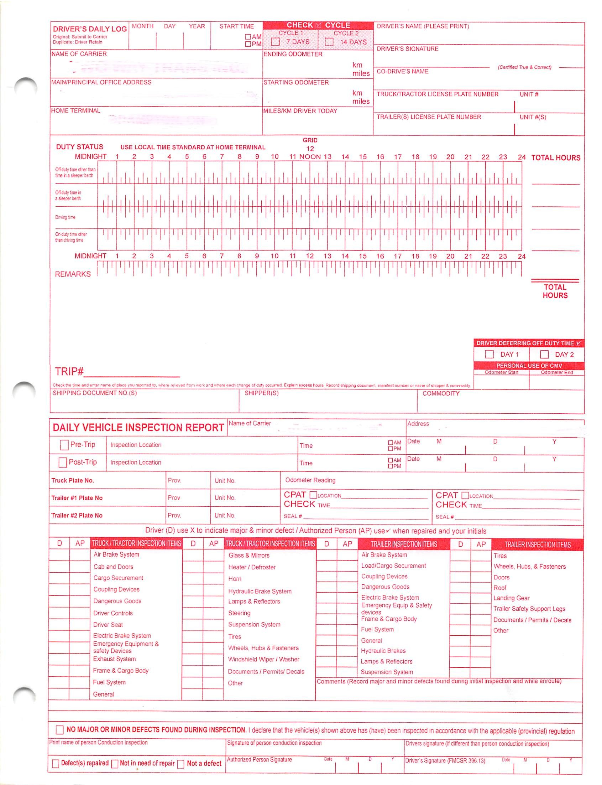

INDEPENDENT CONTRACTOR AGREEMENT
BETWEEN:
DST Transportation
(“DST Transportation”)
-and-
____________________________________________
(the “Contractor”)
1. THE PARTIES

DST Transportation
DST Transportation is a leading provider of expedited transportation and logistics solutions offering LTL and full load in Ontario and Québec.
The Contractor
The Contractor is an independent business entity which carries on business, providing driver services and transportation logistics support. The Contractor is an Independent Contractor which offers and provides non-exclusive driver services and logistics support to the transportation industry at large.

2. AGREEMENT – The Basics
This Agreement as well as the attached “Appendix “A” forms the entire agreement between the parties. By signing this Agreement, the Contractor agrees to all of the terms included below and the specific terms set out within the attached Appendix “A”. The essential features of this Agreement (without limiting the terms set out within Appendix “A”) are as follows:

- The Contractor is an Independent Contractor responsible for its own employees, including hiring, firing, discipline, compensation, benefits and/or insurance.
- The Contractor agrees that its relationship with DST is exclusively that of and Independent Contractor.
- The Contractor further agrees that should the relationship between it, its employees and DST Transport be deemed an employment relationship by any Court or Government Body, the Contractor will be responsible for any costs, damages, penalties, and/or tax remittances which arise, and it hereby specifically indemnifies DST Transport in regard to any such claims. Further, in such event, any deemed employment agreement may be terminated by DST by providing the minimum notice (or pay in lieu) and severance (if applicable), required under the Canada Labour Code.
- This Agreement is for a five-year term, however it may be terminated without cause by either party during the term, by providing 14 days written notice.
- There are no standard or specific hours of work, however the Contractor will make itself and its employee(s) available at such times as are necessary to undertake the transportation of goods,on

behalf of customers of DST Transport.
- The Contractor is liable for any damages caused by its employees, whether to property or equipment.
- The Contractor agrees that by signing this Agreement, it is also agreeing to the terms and conditions set out with in the attached Appendix “A”, which forms part of this Agreement.
- The Contractor acknowledges and agrees that it including its officers, directors, employees and the like have had an opportunity to review this Agreement (including Appendix “A”) with legal counsel, and have done so, or chosen not to do so, of their own volition.

Dated: _________________________  DST Transportation  By: __________________________  Name: ________________________  Title: _________________________ | CONTRACTOR  By: ____________________________  Name: __________________________  Title: Subcontractor .

Witness:_________________________

Note: Attached Appendix “A” which forms part of this Agreement

APPENDIX “A” Specific Terms- Independent Contactor Agreement

1. TERM The term of this Agreement shall commence on the date signed (or is otherwise mutually agreed by the Parties) and terminate automatically at the end of 5 years (the “Expiration Date”) unless extended by mutual written agreement of both Parties no later than sixty (60) days before the Expiration Date. DST Transport may terminate this Agreement at any time before (or after) the Expiration Date upon fourteen (14) days written notice to the Contractor, or without notice if the Contractor breaches a material term of this Agreement. This clause shall survive the termination of this Agreement. The Contractor is not an employee of DST Transport, however in the event that this Agreement or the relationship it describes is ever deemed an employment agreement by any court of competent jurisdiction or government body, such employment relationship may be terminated by DST Transport (where just cause does not exist), by providing such deemed employee(s) with the minimum notice (or termination pay) and severance pay (if applicable), required under the Canada Labour Code. This clause shall survive the termination of this Agreement. Further, should the Contractor (or any of its employees) be deemed to be employees of DST Transport by any court of competent jurisdiction or government body, the Contractor including any deemed employee, will be solely responsible for payment of all accrued employee obligations (backdated to the date of this Agreement), including but not limited to, any employee obligations to the Canada Revenue Agency for income tax, Canada Pension Plan and Employment Insurance contributions, applicable Employee Health Tax payments and/or any applicable obligations under workers compensation legislation of the applicable province or territory (in Ontario, the Workplace Safety and Insurance Act). This clause shall survive the termination of this Agreement. 2. SERVICES TO BE PROVIDED The Contractor shall perform driver supply and logistics services as required under this Agreement (if applicable, as more fully described in Appendix “A” to this Agreement) and, in addition, shall perform such other services as DST Transport may assign from time to time (the “Services”). The Contractor may deliver such Services through the use of any of its own employees, provided however, such employees are insurable, bondable, have clean driving abstracts, and applicable commercial drivers’ license (CDL), as well as such training and licenses as required for the safe transport of the goods being carried in relation to this Agreement. Should the Contractor undertake Services which require the transportation of goods to or from the United States of America, its employees undertaking such services on its behalf shall be able to meet all United States legal requirements for entry and cross-border transportation, including but not limited to any drug testing requirements made necessary on account of United States Department of Transportation rules and regulations. The Contractor agrees to provide evidence of meeting such applicable requirements upon request of DST Transport. DST Transport grants the Contractor the authority and discretion to do such things as may be reasonably necessary for the purposes of performing the Services. However, the Contractor shall not have the authority or discretion to enter into any agreement, contract or understanding that legally binds DST Transport or otherwise assume, create or incur any obligations or liabilities on behalf of DST Transport, except as expressly provided for in this Agreement, without first obtaining the prior written consent of DST Transport.
3. FEES In consideration of the Services provided, DST Transport shall pay to the Contractor the fees set out within Appendix “A” to this Agreement, or as otherwise negotiated by the Parties and reduced to writing. The Contractor shall submit an invoice for Services rendered. The Contractor agrees to clearly reference the applicable HST registration number on all such invoices provided to DST Transport. Payment shall be made in accordance with the usual practice of DST Transport, or otherwise as specifically agreed in writing by the Parties. 4. HOURS OF WORK There shall be no stipulated or set hours of work. The Contractor and its employees agree to be reasonably available to provide Services to DST Transport in order to timely fulfill the needs and expectations of customers of DST Transport. The Contractor and its employees agree to strictly observe all laws concerning hours of service requirements, including but not limited to legislated hours of service and rest periods, the completion of applicable logs and inspections, and the occupational health and safety obligations under Part II of the Canada Labour Code. 5. INDEPENANT CONTRACTOR The Contractor is an shall remain at all times an independent contractor, and shall not represent itself (or its employees) to be agents, officers or employees of DST Transport or as being related to DST Transport in any way other than as an independent contractor. The Contractor (and where applicable its employees), agree(s) not to make any representations or engage in any acts which could establish an apparent relationship of agency or employment with DST Transport. In the event that the Contractor, its officers, shareholders or directing minds violate such agreement, the Contractor shall be liable to DST Transport for all damages however caused, including but not limited to the payment of the legal fees of DST Transport which arise on account of such violation. For greater certainty, DST Transport shall not be bound by any agreement, contract, representation or warranty made by the Contractor, except where the Contractor has first obtained the written consent of DST Transport. Nothing in this Agreement is intended to create nor shall be construed as creating an employment relationship between the Contractor and DST Transport, or DST Transport and any employee, officer or director of the Contractor. The Contractor has sole responsibility as an independent contractor, to comply with all laws, rules and regulations relating to the provision of Services, including without reservation, requirements under the Income Tax Act (Canada), the Employment Insurance Act (Canada), the Employer Health Tax Act (Ontario) and the Canada Pension Plan Act relative to its employees. The Contractor shall be solely responsible for deducting any and all applicable federal and provincial taxes, deductions, premiums, and amounts owing with respect to (or related to) those Fees paid by DST Transport and remitting in a timely manner such amounts to those governmental authorities as maybes prescribed by law. As an independent contractor, the employees of the Contractor shall not be entitled to any employment related benefits from DST Transport, including without limitation, any payments under the Canada Labour Code or similar legislation respecting employment standards. Upon termination of this Agreement for any reason, DST Transport shall be responsible for paying to the Contractor, only the Fees associated with the Services up to and including the last date on which the Contractor provided Services to DST Transport. Unless specifically granted by legislation, the employees of the Contractor shall have no further claim or cause of action against DST Transport (including as against the officers and directors of DST Transport), for any cause, matter or thing relating to an alleged employment relationship between the Contractor and DST Transport, including, without limitation, any claim for reasonable notice of termination, pay in lieu of notice, termination, severance or
vacation pay, expenses, bonus or incentive plan payments, overtime pay, group benefits are pension entitlements whether arising pursuant to statute, contract, common law or otherwise. This Section shall survive the termination of this Agreement and remain binding upon the Contractor. The Contractor is solely responsible for disciplining its own employees and managing the human resources and other affairs of its business. Further, as an independent contractor, the Contractor warrants that it (and its employees) offers and provides services to other transportation companies (including competitors of DST Transport), and will continue to do so at its discretion, provided that it does not in any way use the resources and/or property (buildings, land, trucks, trailers, etc., whether owned or leased) of DST Transport, to undertake such services. Pursuant to this Agreement (which constitutes a contract for service), the Contractor may accept or reject “work” offered to it by DST Transport, however once accepted, must complete such Services in a professional and timely manner, in accordance with the terms of this Agreement. 6. WARRANTY The Contractor agrees to provide the Services in a competent, efficient, professional, timely and safe manner and all times in compliance with (i) the applicable law; (ii) DST Transport policies, rules, systems and procedures as shall be in force and applicable to independent contractors; and (iii) the terms of this Agreement. 7. REGISTRATIONS The Contractor shall have a HST registration number and shall be responsible for deducting and remitting HST to the applicable regulatory authorities in accordance with the Excise Tax Act (Canada).

8. HEALTH AND SAFETY / INDEMNITY The Contractor shall comply with all health and safety obligations under Part II of the Canada Labour Code, the Workplace Safety and Insurance legislation within the province it operates and hereby agrees to indemnify and hold harmless DST Transport, its officers, directors, representatives, agents and employees from and against any and all claims, demands, suits, losses, fines, surcharges, damages, costs and expenses arising out of the Contractor’s failure to comply with such laws. The Contractor further agrees to indemnify and hold DST Transport, its officers, directors, representatives, agents and employees harmless from and against any and all liabilities, claims, demands, suits, losses, fines, costs and expenses relating to the injury or death of any person, damage to or destruction of any property, which is directly or indirectly caused by any act or omission on the part of the Contractor or any employees of the Contractor, engaged in providing Services to DST Transport. The Contractor further specifically agrees to be liable to DST Transport for any damages caused by it or its employees to equipment or property owned or leased by DST Transport, and shall remit full payment for such damages, immediately upon request by DST Transport. The Contractor also agrees to indemnify and hold harmless DST Transport from and against all losses, liabilities and expenses relating to any claim, action, application or suit by its employee alleging that he or she is employed by DST Transport in respect of performing Services under this Agreement. This Appendix “A” is a material part of the attached Independent Contractor Agreement entered into between the parties, and it cannot be amended except by mutual written agreement of the parties. _____________________________________________________________________________________

